**ST. JOHN’S COMPREHENSIVE SECONDARY SCHOOL**

**END OF TERM I**

**GEOGRAPHY 273/1**

**S.1**

**TIME:** 1 hour 30 minutes

**INSTRUCTIONS**: -Answer only **TWO** items

-you may use relevant diagrams to illustrate your answers

Item 1.

Sayuni a student of Kabale SS has been reported by her class teacher of dodging geography lessons. She was called in the disciplinary committee and asked why she does not attend geography lesson and she said studying geography was wastage of time since she wanted to become a doctor in future.

Support material

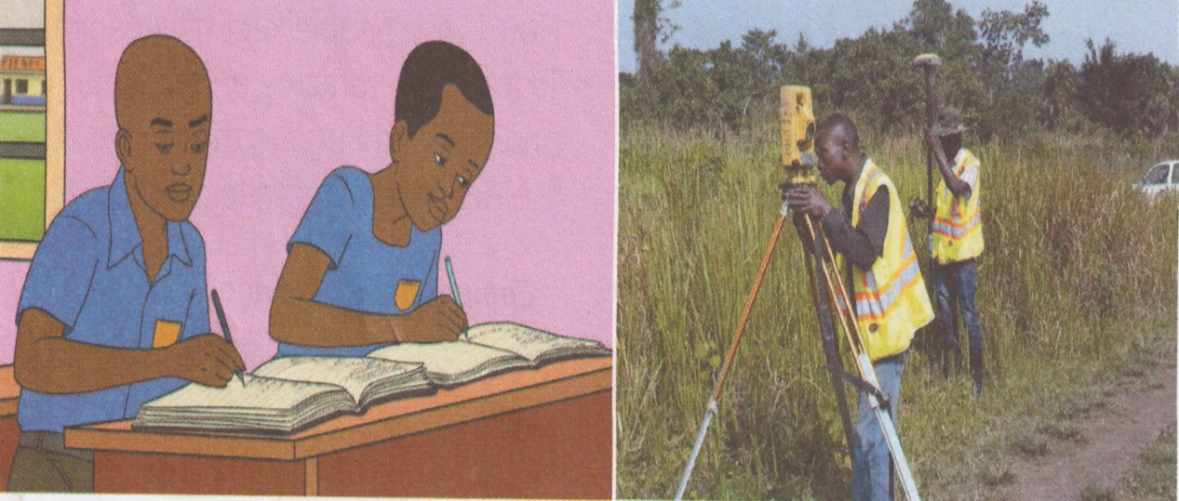

Task

Advise Sayuni on the need to attend geography lessons.

Item 2.

Steven has been admitted into senior one in a school far away from his home. His elder brother James who had just come back from USA wanted to go and visit Steven on the school Visitation day. Steven’s mother tried to explain to James the route to the school but still he could not find the school.

Support material

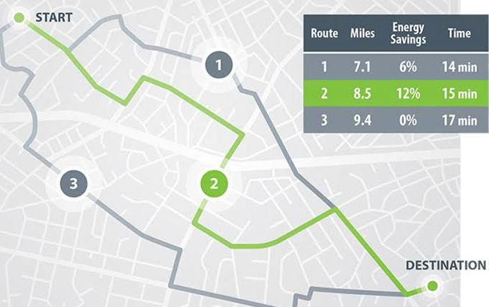 

Task

As a student who has studied (following routes on a map), assume that your are selected to direct James from your home to your school, with the help of a route map, help James to reach your school.

**END**